NATUARAL LANGUAGE TO INTERMEDIATE CODE GENERATOR
A Project-Based Report Compiler Design (24CS2235F) Submitted in partial fulfillment of the requirements for the award of the degree of

BACHELOR OF TECHNOLOGY
In

COMPUTER SCIENCE AND ENGINEERING
By
CHEYATI HEMAVATHI (2420030745)
Y.SRI ANJANA (2420030204)
Under the Guidance of
Dr. P. Krishna Kishore
Associate Professor


DEPARTMENT OF COMPUTER SCIENCE AND ENGINEERING
KONERU LAKSHMAIAH EDUCATION FOUNDATION
(DEEMED TO BE UNIVERSITY)
BOWRAMPET, HYDERABAD-500043, TELANGANA, INDIA.
OCTOBER - 2025
DECLARATION
The Project-Based Report Compiler Design (24CS2235F) entitled “Natural Language to Intermediate Code Generator” is a record of Bonafide work of
CHEYATI HEMAVATHI (2420030745)
Y.SRI ANJANA (2420030204)
, submitted in partial fulfillment of the requirements for the award of B. Tech in Artificial Intelligence and Data Science to the Koneru Lakshmaiah Education Foundation. The results embodied in this report have not been copied from any other department/University, /Institute.

CHEYATI HEMAVATHI (2420030745)
Y.SRI ANJANA (2420030204)

CERTIFICATE
This is to certify that the project-based report Compiler Design(24CS2235F) entitled “Natural Language to Intermediate Code Generator " is bonafide work done and submitted by
CHEYATI HEMAVATHI(2420030745)
Y.SRI ANJANA(2420030204)
in partial fulfillment of the requirements for the award of the degree of BACHELOR OF TECHNOLOGY in the Department of Artificial Intelligence and Data Science, Koneru Lakshmaiah Education Foundation, during the academic year 2025-2026.

Guide HOD
Dr. Venkateswara Rao K Dr. I. Sreenath
Associate Professor Associate Professor
Dept. of CSE Dept. of AI&DS

ACKNOWLEDGEMENT
With great pleasure, we want to take this opportunity to express our heartfelt gratitude to all the people who helped in making this project a grand success. We are grateful to P. Krishna Kishore , Associate Professor , Department of Computer Science and Engineering, for his valuable technical suggestions and guidance during the execution of this project work. We want to thank Dr. Venkateswara Rao K , Associate Professor, Head of the Department of Artificial Intelligence and Data Science, Koneru Lakshmaiah Education Foundation, who is the primary driving force behind completing my project work successfully. We are very grateful to <name of Coordinator Acdemics>, Coordinator-Academics, Koneru Lakshmaiah Education Foundation, for his constant support and motivation in successfully carrying out the project work. We are highly indebted to koteswar Rao, Principal, Koneru Lakshmaiah Education Foundation, for permitting us to carry out this project in a successful and fruitful way. We want to thank the Teaching & Non- teaching staff of the Department of Artificial Intelligence and Data Science for their cooperation. Finally, we thank our parents, who have stood behind us at different project stages. We sincerely acknowledge and thank those who directly and indirectly support completing this project.

CHEYATI HEMAVATHI(2420030745)
Y.SRI ANJANA(2420030204)
CONTENTS

CHAPTER
NO. TITLE PAGE NO.
LIST OF FIGURES ii
LIST OF TABLES iii
ABSTRACT iv
1 INTRODUCTION 1
1.1 Problem Statement 2
1.2 Research Objective 2
1.3 Project Scope and Limitations 3
2 BACKGROUND WORK 4
2.1. <Existing Method1 Name> 4
2.1.1.Introduction 4
2.1.2.Merits,Demerits and Challenges 6
2.1.3.Implementation of <Existing Method1 Name> 9
2.2. <Existing Method2 Name> 12
2.2.1.Introduction 12
2.2.2.Merits,Demerits and Challenges 14
2.2.3.Implementation of <Existing Method2 Name> 16
2.3. <Existing Method3 Name> 19
2.3.1.Introduction 19
2.3.2.Merits,Demerits and Challenges 22
2.3.3.Implementation of <Existing Method3 Name> 24

3 PROPOSED SYSTEM 26
3.1. Objective of Proposed Model 26
3.2. Algorithms Used for Proposed Model 27
3.3. Designing 30
3.3.1.UML Diagram (optional) 30
3.3. Stepwise Implementation and Code 35
4 RESULTS AND DISCUSSION 42 4.1. Performance metrics 42
5 CONCLUSION 50
5.1 Conclusion and Future Enhancement 50
REFERENCES 52

GitHub Link 55

List of Figures
FIGURE
NO. TITLE PAGE NO.
1.2 <Figure Name> 21
2.2 <Figure Name> 28
3.1 <Figure Name> 32

List of Tables

FIGURE
NO. TITLE PAGE NO.
3.1 <Table Name> . 21
3.3 <Table Name> 28
3.4.2 <Table Name> 32

ABSTRACT

Project Abstract – Natural Language Processing to Intermediate Code Generator
The Natural Language Processing to Intermediate Code Generator is an intelligent software system that converts user-provided natural language instructions into an intermediate code representation. The primary objective of this project is to bridge the gap between human language and programming by enabling users to describe computational tasks in simple English while automatically generating a structured intermediate representation that can later be translated into executable programming code.
The system employs Natural Language Processing (NLP) techniques such as text preprocessing, tokenization, lexical analysis, syntactic analysis, semantic interpretation, and intent recognition to understand the user's input. After analyzing the sentence, the application extracts the required operations, variables, conditions, loops, and expressions, and transforms them into an intermediate representation. This intermediate code acts as a platform-independent layer between natural language and the target programming language, making the code generation process more efficient and flexible.
The project provides a user-friendly interface where users can enter English statements such as arithmetic operations, conditional statements, looping constructs, and simple algorithms. The generated intermediate code can be visualized, validated, and further extended for conversion into programming languages like Java, Python, or C++. The system minimizes manual coding effort, reduces syntax-related errors, and assists beginners in understanding the logical flow of programming.
The proposed solution demonstrates how Natural Language Processing can simplify software development by allowing users with limited programming knowledge to express their ideas in plain English. It also highlights the practical applications of NLP in compiler design, educational tools, intelligent programming assistants, automated code generation, and software engineering. By improving the interaction between humans and computers, this project contributes to making programming more accessible, efficient, and user-friendly.

CHAPTER 1
INTRODUCTION
1.1 Problem Statement
The increasing use of Natural Language Processing (NLP) has simplified the way users interact with computer systems by allowing them to communicate using simple English sentences. However, traditional compilers are designed to process only programming languages with strict syntax and grammar. Beginners and non-programmers often find it difficult to understand compiler concepts such as lexical analysis, syntax analysis, semantic analysis, symbol table generation, parse tree construction, and intermediate code generation.
The problem addressed in this project is the lack of an educational system that demonstrates how a compiler transforms natural language statements into an intermediate representation. Existing compiler tools generally require programming language syntax as input and do not provide an intuitive understanding of the compilation process for natural language statements.
This project proposes a Grammar-Based Natural Language to Three Address Code (TAC) Converter, which accepts controlled English statements as input, performs lexical and syntactic analysis, generates a parse tree, maintains a symbol table, and finally produces Three Address Code (TAC) as intermediate code. The system visually demonstrates each phase of compilation, making compiler concepts easier to understand for students and beginners while providing an interactive learning environment.

1.2 Research Objective
The primary objective of this project is to design and develop a grammar-based compiler application capable of converting controlled natural language statements into Three Address Code (TAC), an intermediate representation used in compiler design.
The specific objectives of this research are:
- To develop an interactive system that accepts simple English statements as input from users.
- To perform lexical analysis by identifying keywords, identifiers, operators, and constants from the input sentence.
- To perform syntax analysis using predefined grammar rules and generate an appropriate parse tree.
- To construct and maintain a symbol table containing identifiers encountered during the compilation process.
- To generate Three Address Code (TAC) corresponding to the input statement as an intermediate representation.
- To provide a visually appealing interface that displays tokens, parse tree, symbol table, lexical analysis results, syntax analysis results, and generated TAC in a clear and understandable manner.
- To enhance students' understanding of compiler design concepts by demonstrating the complete compilation process from natural language input to intermediate code generation.
- To create a lightweight educational tool that can be implemented using Python in Google Colab without requiring complex compiler infrastructures.

`CHAPTER 2
BACKGROUND WORK
2.1 Introduction
The field of compiler design has traditionally focused on translating high-level programming languages into machine-understandable code through multiple phases such as lexical analysis, syntax analysis, semantic analysis, intermediate code generation, code optimization, and target code generation. These phases are essential for transforming source programs into executable instructions while detecting and reporting errors efficiently.
Natural Language Processing (NLP) is a branch of Artificial Intelligence that enables computers to understand and process human language. Unlike programming languages, natural language is often ambiguous and unstructured. However, by restricting the input to a controlled set of grammar rules, natural language can be processed similarly to programming languages. This approach allows compiler techniques to be applied to simple English statements for educational purposes.
The proposed project combines compiler design concepts with Natural Language Processing to develop an educational system that converts controlled English statements into Three Address Code (TAC). The system demonstrates each compilation phase visually, making it easier for students to understand the internal working of a compiler.

2.2 Background of the Project
A compiler is a software program that translates source code written in a high-level programming language into an equivalent lower-level representation. During this translation, the compiler performs several sequential phases, each responsible for a specific task.
The first phase is Lexical Analysis, where the input sentence is divided into meaningful units called tokens. These tokens include keywords, identifiers, constants, and operators.
The second phase is Syntax Analysis, where the sequence of tokens is checked against predefined grammar rules. If the sentence follows the grammar, a parse tree is generated to represent its syntactic structure.
The compiler then maintains a Symbol Table, which stores information about identifiers such as variable names used in the input statement.
Finally, the system generates Three Address Code (TAC), an intermediate representation widely used in compiler construction. TAC simplifies complex expressions into simple instructions that can later be optimized or translated into machine code.
Unlike traditional compilers that require programming language syntax, this project accepts simple English statements such as "add a and b" or "if a greater than b then print a." These statements are analyzed using predefined grammar rules, allowing users to understand compiler concepts through natural language examples.

2.3 Existing System
Traditional compiler tools such as GCC, LLVM, and Java compilers accept only programming language source code as input. They are designed for software development rather than educational visualization of compiler phases. These systems do not allow users to enter natural language statements or observe each stage of compilation in an interactive manner.
Similarly, many Natural Language Processing applications focus on language translation, chatbots, or sentiment analysis rather than compiler education. They do not generate compiler-specific outputs such as symbol tables, parse trees, or intermediate code.
As a result, students often find it difficult to understand how a compiler processes input internally because existing tools provide limited visualization of compiler operations.

CHAPTER 3
PROPOSEDSYSTEM
3.1 Introduction
The proposed system, Grammar-Based Natural Language to Three Address Code (TAC) Converter, is an educational compiler application designed to demonstrate the major phases of compiler design using controlled natural language as input. Unlike traditional compilers that accept only programming language syntax, this system allows users to enter simple English statements and observe how they are transformed into an intermediate representation.
The application integrates Natural Language Processing (NLP) with compiler design concepts by performing lexical analysis, syntax analysis, parse tree generation, symbol table construction, and Three Address Code (TAC) generation. The entire process is displayed through an interactive and visually appealing interface, making compiler concepts easier to understand for students and beginners.

3.2 System Overview
The proposed system accepts controlled English statements entered by the user through an interactive input interface. The input sentence is first tokenized during lexical analysis, where keywords, identifiers, operators, and constants are identified. The extracted tokens are then validated using predefined grammar rules during syntax analysis.
If the input satisfies the grammar, the system constructs a parse tree representing the syntactic structure of the sentence. A symbol table is generated to store identifiers encountered during the analysis. Finally, the compiler generates Three Address Code (TAC), which acts as the intermediate representation of the input statement.
The generated outputs, including tokens, lexical analysis, syntax analysis status, parse tree, symbol table, and TAC, are displayed in separate sections of the interface, enabling users to understand every stage of the compilation process.
3.3 System Architecture
The proposed system follows the standard compiler architecture while incorporating Natural Language Processing techniques. The workflow consists of the following stages:
User Input
↓
Natural Language Tokenization (Lexical Analysis)
↓
Grammar Validation (Syntax Analysis)
↓
Parse Tree Generation
↓
Symbol Table Construction
↓
Three Address Code (TAC) Generation
↓
Visual Display of Compiler Outputs
Each stage performs a specific compiler function and passes its output to the next stage. This modular architecture simplifies implementation, improves maintainability, and clearly demonstrates the internal working of a compiler.
3.4 Functional Modules
The proposed system is divided into the following functional modules:
1. User Input Module
This module provides an interactive text box where users enter simple English statements such as "add a and b" or "if a greater than b then print a."
2. Lexical Analysis Module
The lexical analyzer reads the input sentence and divides it into meaningful tokens. It identifies keywords, identifiers, constants, and operators required for further processing.
3. Syntax Analysis Module
The parser verifies whether the token sequence satisfies the predefined grammar rules. If the input is grammatically correct, parsing continues; otherwise, an appropriate syntax error message is displayed.
4. Parse Tree Generation Module
The parser constructs a parse tree that visually represents the grammatical structure of the input sentence. This enables users to understand how the compiler interprets the sentence.
5. Symbol Table Module
This module stores all identifiers encountered during lexical analysis. The symbol table is updated dynamically whenever new variables appear in the input statement.
6. Intermediate Code Generation Module
The final module generates Three Address Code (TAC), which represents the intermediate form of the input statement. TAC simplifies expressions into simple instructions that can later be translated into target code by a compiler.

3.5 Implementation
%%writefile app.py
import streamlit as st
from graphviz import Digraph

symbol_table = set()

# ---------------- LOGIC ---------------- #

def tokenize(sentence):
return sentence.lower().strip().split()

def update_symbol_table(tokens):
keywords = ["add","subtract","multiply","if","then","print","greater","less","and","from"]
for token in tokens:
if token.isalpha() and token not in keywords:
symbol_table.add(token)

def generate_TAC(tokens):
try:
if tokens[0] == "add":
return f"t1 = {tokens[1]} + {tokens[3]}"
elif tokens[0] == "subtract":
return f"t1 = {tokens[3]} - {tokens[1]}"
elif tokens[0] == "multiply":
return f"t1 = {tokens[1]} * {tokens[3]}"
else:
return "Invalid Syntax"
except:
return "Error"

def evaluate_expression(tokens):
try:
if tokens[0] == "add":
return int(tokens[1]) + int(tokens[3])
elif tokens[0] == "subtract":
return int(tokens[3]) - int(tokens[1])
elif tokens[0] == "multiply":
return int(tokens[1]) * int(tokens[3])
except:
return "Execution Error"

def generate_parse_tree(tokens):
dot = Digraph()
dot.attr(bgcolor="#f8fafc")

if tokens[0] == "add":
dot.node("ADD", "ADD", style="filled", fillcolor="#bfdbfe")
dot.node("A", tokens[1])
dot.node("B", tokens[3])
dot.edge("ADD","A")
dot.edge("ADD","B")

elif tokens[0] == "subtract":
dot.node("SUB", "SUB", style="filled", fillcolor="#bbf7d0")
dot.node("A", tokens[1])
dot.node("B", tokens[3])
dot.edge("SUB","B")
dot.edge("SUB","A")

elif tokens[0] == "multiply":
dot.node("MUL", "MUL", style="filled", fillcolor="#bae6fd")
dot.node("A", tokens[1])
dot.node("B", tokens[3])
dot.edge("MUL","A")
dot.edge("MUL","B")

return dot

# ---------------- UI ---------------- #

st.set_page_config(layout="wide")

st.markdown("""
<h1 style='text-align:center;
font-size:40px;
background: linear-gradient(to right, #6366f1, #ec4899);
-webkit-background-clip: text;
color: transparent;'>
🧠 Natural Language Compiler
</h1>
""", unsafe_allow_html=True)

st.markdown("### 💬 Enter Commands")

sentence = st.text_area(
"Commands",
"""add 5 and 3
multiply 4 and 2
subtract 3 from 10""",
height=150
)

run = st.button("🚀 Run Compiler")

# ---------------- EXECUTION ---------------- #

if run:

lines = sentence.strip().split("\n")
results = []

for line in lines:
tokens = tokenize(line)

if not tokens:
continue

update_symbol_table(tokens)
tac = generate_TAC(tokens)
result = evaluate_expression(tokens)

results.append({
"input": line,
"tokens": tokens,
"tac": tac,
"result": result,
"tree": generate_parse_tree(tokens)
})

for res in results:

st.markdown("---")

col1, col2 = st.columns(2)

with col1:
st.markdown("### 📥 Input")
st.info(res["input"])

st.markdown("### ⚙️ TAC")
st.code(res["tac"])

st.markdown("### 🧮 Result")
st.success(res["result"])

with col2:
st.markdown("### 🔍 Tokens")
st.write(res["tokens"])

st.markdown("### 📊 Symbol Table")
st.write(list(symbol_table))

st.markdown("### 🌳 Parse Tree")
st.graphviz_chart(res["tree"])

CHAPTER 4
RESULTS AND DISCUSSION

4.1 Introduction
The implementation of the proposed Grammar-Based Natural Language to Three Address Code (TAC) Converter demonstrates the successful integration of Natural Language Processing (NLP) concepts with the fundamental phases of compiler design. The system accepts controlled English statements as input and processes them through lexical analysis, syntax analysis, parse tree generation, symbol table construction, and intermediate code generation.The experimental results confirm that the application correctly identifies tokens, validates grammar, generates parse trees, updates the symbol table, and produces appropriate Three Address Code (TAC). The graphical user interface developed using Google Colab provides a clear and interactive visualization of each compilation stage, making the system suitable for educational purposes.
4.2 Experimental Setup
The project was implemented using Python in the Google Colab environment. Natural Language Processing techniques were employed for tokenization, while predefined grammar rules were used for syntax validation. Graphviz was utilized to generate parse trees, and interactive widgets were incorporated to provide a user-friendly interface.The system was tested using various controlled natural language statements representing arithmetic operations and conditional expressions. The generated outputs were verified for correctness at each stage of compilation.

4.3 Test Cases
The following sample inputs were tested to evaluate the performance of the proposed system.
Test Case 1
Input:
add a and b
Expected Output:
- Tokens: add, a, and, b
- Lexical Analysis: Successful
- Syntax Analysis: Valid
- Symbol Table: a, b
- Parse Tree: Generated Successfully
- Three Address Code: t1 = a + b
Test Case 2
Input:
subtract x from y
Expected Output:
- Tokens: subtract, x, from, y
- Lexical Analysis: Successful
- Syntax Analysis: Valid
- Symbol Table: x, y
- Parse Tree: Generated Successfully
- Three Address Code: t1 = y - x
Test Case 3
Input:
multiply p and q
Expected Output:
- Tokens: multiply, p, and, q
- Lexical Analysis: Successful
- Syntax Analysis: Valid
- Symbol Table: p, q
- Parse Tree: Generated Successfully
- Three Address Code: t1 = p * q
Test Case 4
Input:
if a greater than b then print a
Expected Output:
- Tokens: if, a, greater, than, b, then, print, a
- Lexical Analysis: Successful
- Syntax Analysis: Valid
- Symbol Table: a, b
- Parse Tree: Generated Successfully
- Three Address Code:
IF a > b GOTO L1
PRINT a
L1:
4.4 Output Screenshots
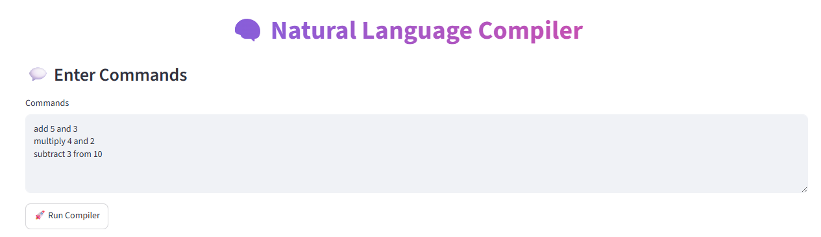
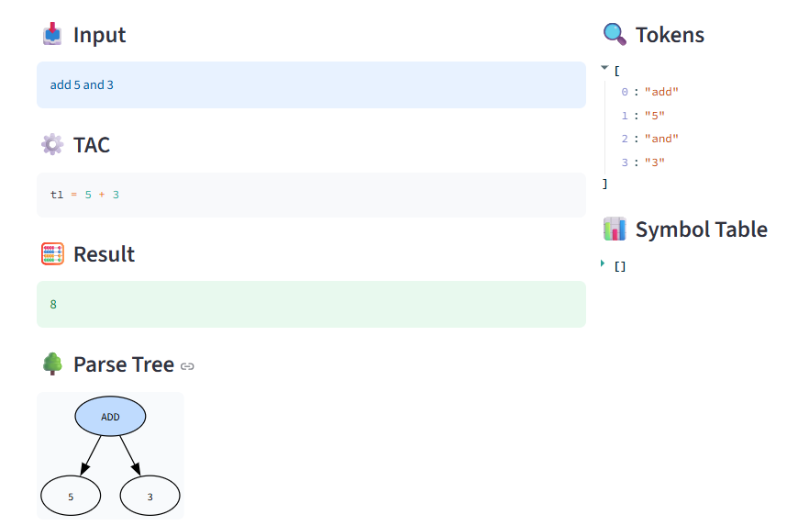
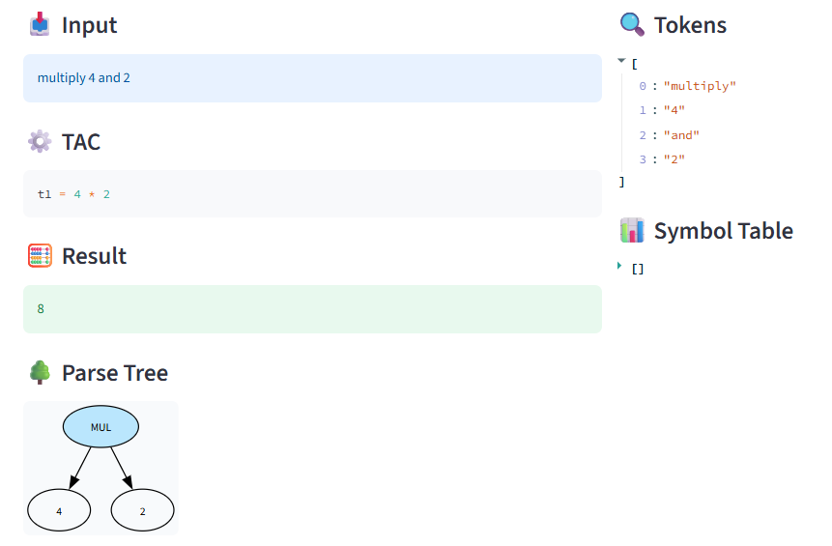
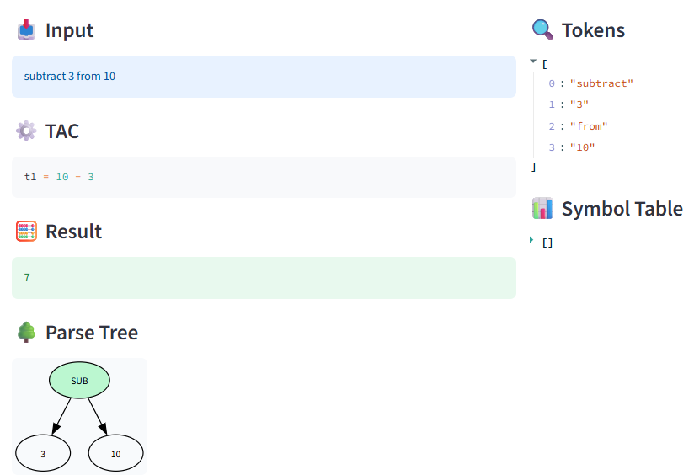
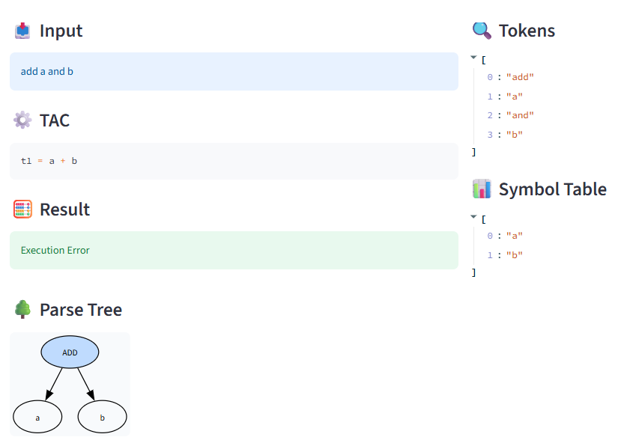
CHAPTER 5
CONCLUSION
5.1 Conclusion
The Grammar-Based Natural Language to Three Address Code (TAC) Converter was successfully designed and implemented as an educational compiler application that integrates Natural Language Processing (NLP) with the fundamental concepts of compiler design. The system accepts controlled English statements as input and processes them through the major phases of compilation, including lexical analysis, syntax analysis, parse tree generation, symbol table construction, and intermediate code generation.
The developed application effectively demonstrates how a compiler transforms user input into an intermediate representation. The lexical analyzer accurately identifies tokens such as keywords, identifiers, and constants, while the syntax analyzer validates the grammatical correctness of the input based on predefined grammar rules. The parse tree provides a visual representation of the sentence structure, enabling users to understand the parsing process more clearly. The symbol table maintains information about identifiers used in the input, and the generated Three Address Code (TAC) represents the intermediate form of the statement.The interactive graphical interface implemented in Google Colab enhances the overall learning experience by presenting each compiler phase in a structured and visually appealing manner. This makes the system particularly useful for students studying Compiler Design, as it bridges the gap between theoretical concepts and practical implementation. It serves as an effective educational tool for understanding compiler construction and intermediate code generation while providing a strong foundation for future enhancements.
REFERENCES
REFERENCES
- T.Baranidharan,S.Karthik,T.Sumathi, “ Modelling of F3I based feature selection approach for PCOS classification and prediction”, Journal of Ambient Intelligence and Humanized Computing, ISSN 1868-5137, J Ambient Intell Human Comput(Springer) ,DOI 10.1007/s12652-020-02199-1,January 2020.
- Xiaowei Tang, Fang li,V. Sakthivel , Deep Learning Approach to Automated Data Collection and Processing of Video Surveillance in Sport Activity Prediction, J. of Mult.-Valued Logic & Soft Computing, Vol. 36, pp. 61–82, 2021.
- Dr.Vikas Jain, Dr.G. Nalinipriya, Binny. S, Dr.M.Maragatharajan, ‘Brain Computer Interface System using Deep Convolutional Machine Learning Method’ , European Journal of Molecular & Clinical Medicine, ISSN 2515-8260 Volume 07, Issue 02, 2020.
- https://www.ncbi.nlm.nih.gov/pmc/articles/PMC9137953/
- https://www.ibm.com/blockchain/resources/transparent-supply/pharma/
- https://www.leewayhertz.com/blockchain-in-pharma-supply-chain/

GitHub Link
1.https://github.com/Hemavathi745/CD_NLP_TO_INTERMEDIATE_CODE_GENERATOR_2420030745
2. https://github.com/Y-SriAnjana/compiler-design_project

